**CODE:**

**Document.java**

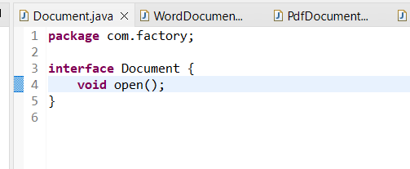

**WordDocument.java**

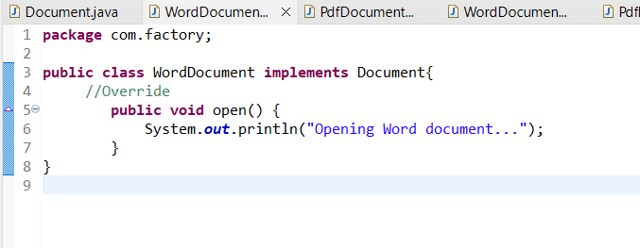

**PdfDocument.java**

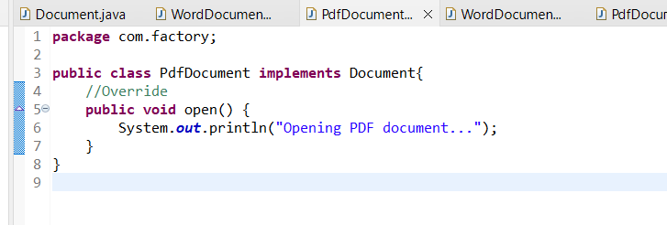

**ExcelDocument.java**

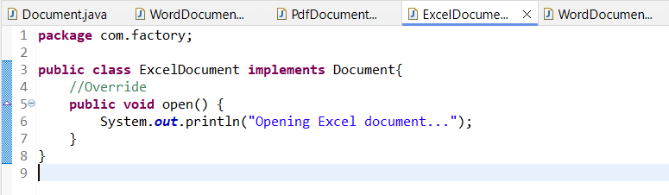

**DocumentFactory.java (Abstract Factory)**

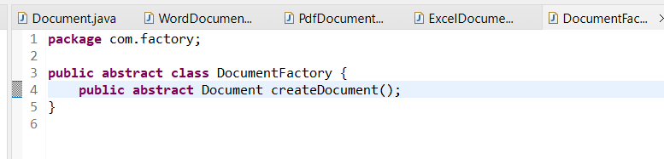

**WordDocumentFactory.java**

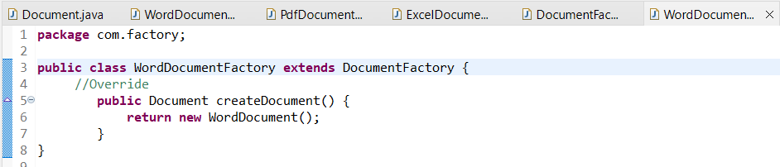

**PdfDocumentFactory.java**

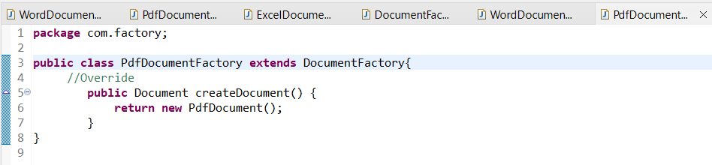

**ExcelDocumentFactory.java**

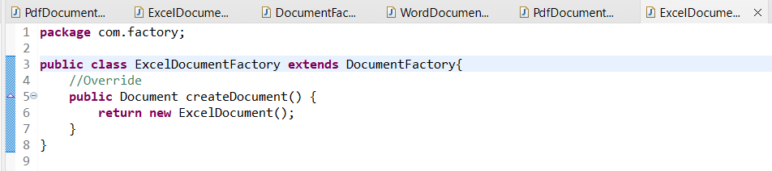

**Main.java**

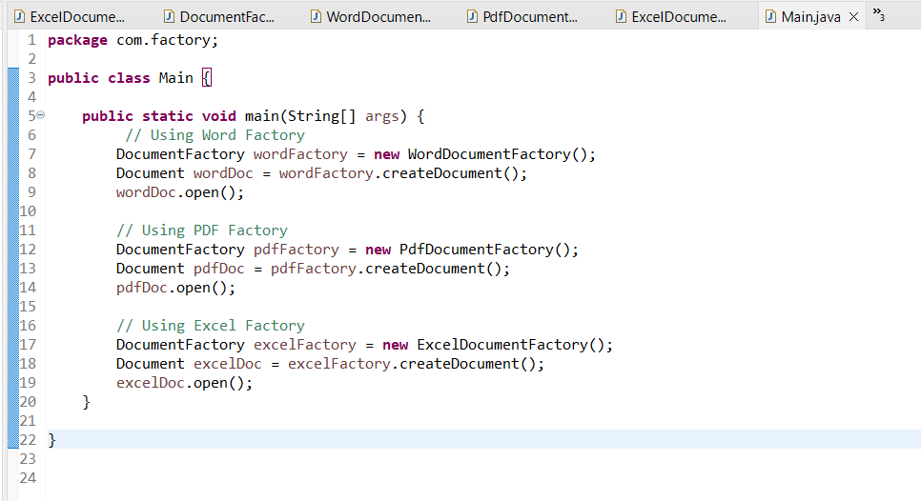

**OUTPUT:**

